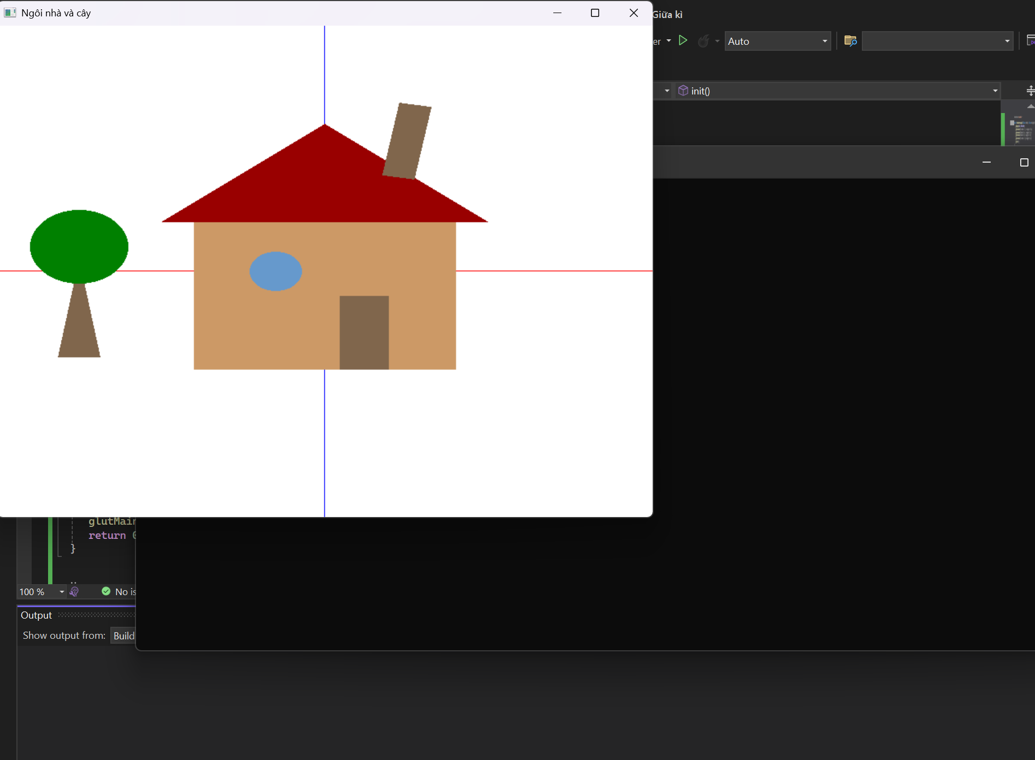#include "glut.h"
#include "math.h"

void drawRectangle(float width, float height) {
glBegin(GL_POLYGON);
glVertex2f(-width / 2, -height / 2);
glVertex2f(width / 2, -height / 2);
glVertex2f(width / 2, height / 2);
glVertex2f(-width / 2, height / 2);
glEnd();
}

void drawTriangle(float base, float height) {
glBegin(GL_TRIANGLES);
glVertex2f(-base / 2, 0);
glVertex2f(base / 2, 0);
glVertex2f(0, height);
glEnd();
}

void drawCircle(float radius) {
glBegin(GL_TRIANGLE_FAN);
glVertex2f(0, 0);
for (int i = 0; i <= 100; i++) {
float angle = i * 2.0f * 3.14159f / 100;
glVertex2f(cos(angle) * radius, sin(angle) * radius);
}
glEnd();
}

void display() {
glClear(GL_COLOR_BUFFER_BIT);

glPushMatrix();
glColor3f(1.0f, 0.0f, 0.0f);
glBegin(GL_LINES);
glVertex2f(-1.0f, 0.0f);
glVertex2f(1.0f, 0.0f);
glEnd();

glColor3f(0.0f, 0.0f, 1.0f);
glBegin(GL_LINES);
glVertex2f(0.0f, -1.0f);
glVertex2f(0.0f, 1.0f);
glEnd();
glPopMatrix();

glPushMatrix();
glColor3f(0.8f, 0.6f, 0.4f);
glTranslatef(0.0f, -0.1f, 0.0f);
drawRectangle(0.8f, 0.6f);
glPopMatrix();

glPushMatrix();
glColor3f(0.6f, 0.0f, 0.0f);
glTranslatef(0.0f, 0.2f, 0.0f);
drawTriangle(1.0f, 0.4f);
glPopMatrix();

glPushMatrix();
glColor3f(0.4f, 0.6f, 0.8f);
glTranslatef(-0.15f, 0.0f, 0.0f);
drawCircle(0.08f);
glPopMatrix();

glPushMatrix();
glColor3f(0.5f, 0.4f, 0.3f);
glTranslatef(0.12f, -0.25f, 0.0f);
drawRectangle(0.15f, 0.3f);
glPopMatrix();

glPushMatrix();
glColor3f(0.5f, 0.4f, 0.3f);
glTranslatef(0.25f, 0.53f, 0.0f);
glRotatef(-10.0f, 0.0f, 0.0f, 1.0f);
drawRectangle(0.1f, 0.3f);
glPopMatrix();

glPushMatrix();
glColor3f(0.5f, 0.4f, 0.3f);
glTranslatef(-0.75f, -0.35f, 0.0f);
glScalef(1.0f, 2.0f, 1.0f);
drawTriangle(0.13f, 0.2f);
glPopMatrix();

glPushMatrix();
glColor3f(0.0f, 0.5f, 0.0f);
glTranslatef(-0.75f, 0.1f, 0.0f);
drawCircle(0.15f);
glPopMatrix();
glFlush();
}

void init() {
glClearColor(1.0f, 1.0f, 1.0f, 1.0f);
glMatrixMode(GL_PROJECTION);
glLoadIdentity();
gluOrtho2D(-1.0, 1.0, -1.0, 1.0);
}

int main(int argc, char** argv) {
glutInit(&argc, argv);
glutInitDisplayMode(GLUT_SINGLE | GLUT_RGB);
glutInitWindowSize(800, 600);
glutCreateWindow("Ngôi nhà và cây");
init();
glutDisplayFunc(display);
glutMainLoop();
return 0;
}

